Summary of **Valley Road Advisory Lanes: A Case Study in Hanover, New Hampshire**

Erica Wygonik, Bill Young, Peter Kulbacki, Carolyn Radisch

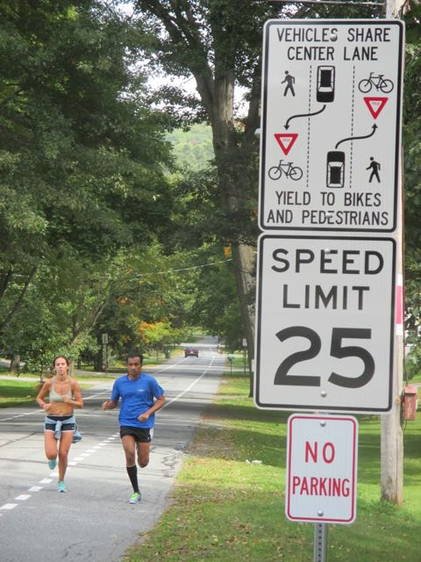**Summary**

Advisory Lanes were painted on about 400 meters of Valley Road in the summer of 2014. Valley Road was selected for the pilot project for the following reasons: two-way residential street with 25 mph speed limit and no sidewalks; important transportation link for pedestrians, cyclists and vehicles between downtown, neighborhoods and schools; low volume of traffic; and approval by most of the neighborhood in a survey and public meeting. Advisory lanes were selected due to the high bike/ped activity, sparse road network limiting options, limited right-of-way, maintenance + plowing costs, and relatively low vehicular traffic volume.

**Monitoring**

As this was a pilot project for the town, monitoring efforts were conducted before and after the installation by a team of volunteer, led by the Hanover Bicycle & Pedestrian Committee. Conditions were observed shortly before and 4 and 16 months following installation. Counts were conducted over 12 hours, and surveys of residents and users were also performed at these intervals.

**Results**

No accidents or other significant problems have occurred. As summarized in Figure 1, vehicular traffic volume decreased at 4 and 16 months, and the number of pedestrians (walkers, joggers, skate boarders) and bicyclists increased. Observers judged that most vehicles are going slower, but some are still speeding. Objective traffic speed data comparisons are not possible due to data corruption.

Nearly all the street users interviewed on April 29, 2016 strongly supported the Advisory Lanes, felt more comfortable walking, and judged the pilot condition was equally or more safe than before.

Figure 1: 12-Hour Count Data on Valley Road



People walking, biking or driving on the streets and the traffic counters raised the following safety concerns. Two novice preadolescent bicyclists made poor stops as they entered from a side street. They did stop before crossing the advisory lane dashed line but it was close. Two alert drivers slowed down significantly. It is possible the advisory lanes helped both the drivers and cyclists. Second, a lawn care truck was parked for 2 hours in the North advisory lane. All walkers and bikers needed to swing out in to the traffic lane. Third, two regular street pedestrians judged that many cars traveling in the central travel lane pass walkers in the advisory lane with less clearance. In the past cars moved further to the opposite side. No one interviewed reported a close call or accident.

**Future Action**

The pilot has been deemed a success, especially as it has informed the department of public works’ and police departments’ development of criteria for future installations. These criteria have been advanced to the Select Board for final adoption and are as follows:

* Neighborhood or Bicycle/Pedestrian Committee request,
* Concurrence from the Select Board,
* Less than 1,000 vehicles per day,
* At least 500’ of site distance,
* Adequate road width to allow a single vehicle to pass pedestrians and bicyclists without leaving the center lane,
* Low volume of conflict related accidents (<2/year),
* Pedestrians exceed >10% of the vehicular volumes.
* 85th percentile speed less than 30 mph,
* No on-street parking allowed.

In addition, there has been considerable national and local interest in Hanover’s advisory lane pilot. Town staff and the Chair of the Bicycle & Pedestrian Committee have fielded inquiries from across the US and Canada. A proximate neighborhood has requested them (https://ripadvisory.wordpress.com/), and local residents have developed a video advertising their use (https://vimeo.com/198050122).